- Building a simple Power BI Report
1.1 Working with Power BI Model
In the modeling view the relationship between FactInternetSales and DimDate based on OrderDate has been set as active. All redundant or secondary date relationships were removed. The table DimProductCategory was connected to FactInternetSales table through the bridge table DimProductSubcategory. Tables SalesByCountry, SalesByYearsNPrice and FactInternetSalesReason were not used in the analysis so they were not connected to the FactInternetSales. SalesByCountry and SalesByYearsNPrice were identified as auxiliary tables for practice purposes. FactInternetSalesReason, being a separate fact table, was kept independent as it was not required for the specific measures in this analysis. The final variant of the established data model for analyzing:
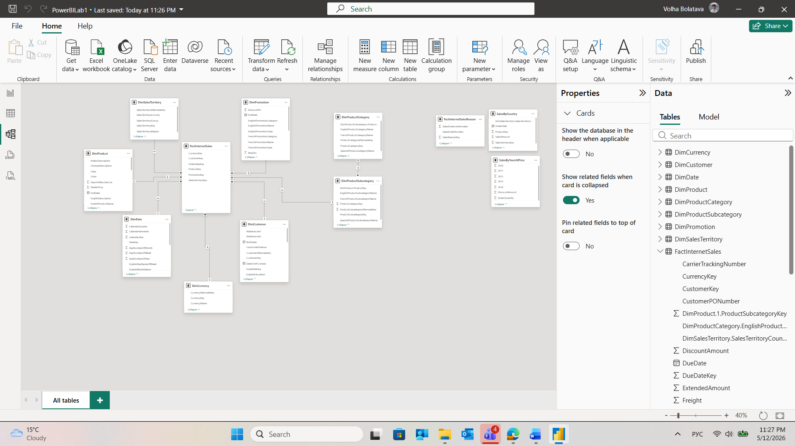
1.2 Working with Power BI Report
A slicer for Full Name (from the DimCustomer table) was added. The slicer was configured in two formats — List (for quick selection) and Dropdown (to save canvas space). Enabled the Search option for both slicer types. This allows users to quickly filter through the extensive customer list, significantly improving navigation efficiency.
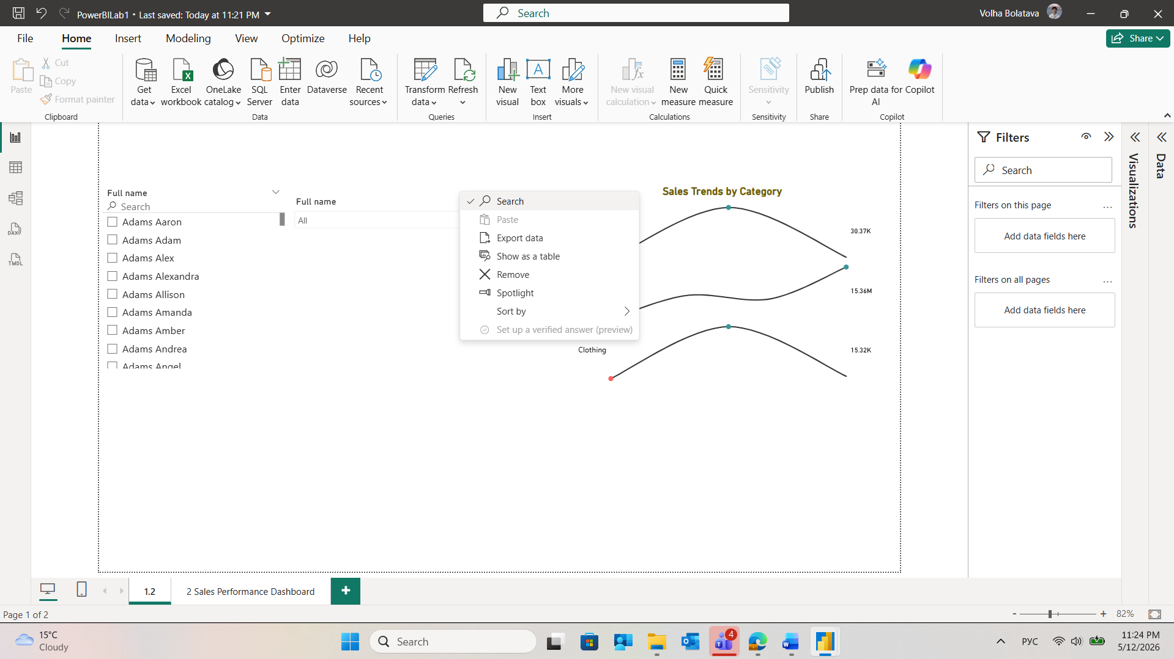
Custom visual Sparkline by OKVIZ from the Marketplace was added. Sparkline by OKVIZ is a versatile visual that lets you display trends for multiple measures or category items in a compact, fully customizable format. And it was used to present sales trend by categories:
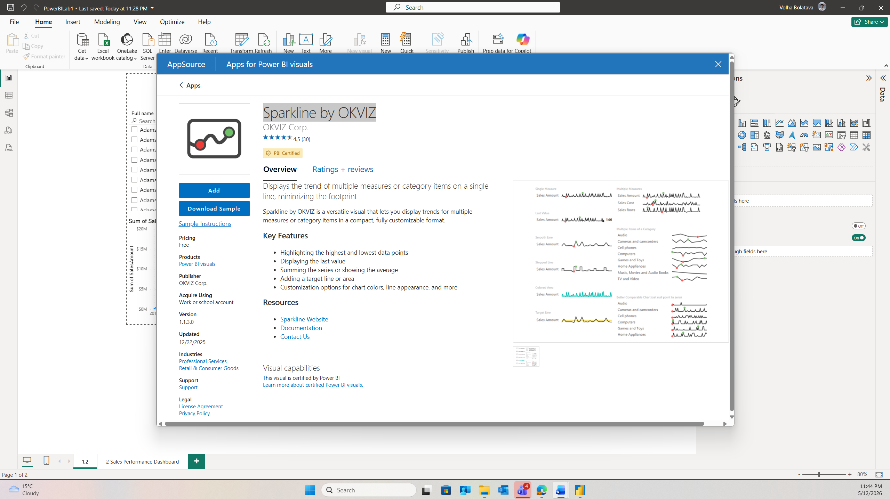
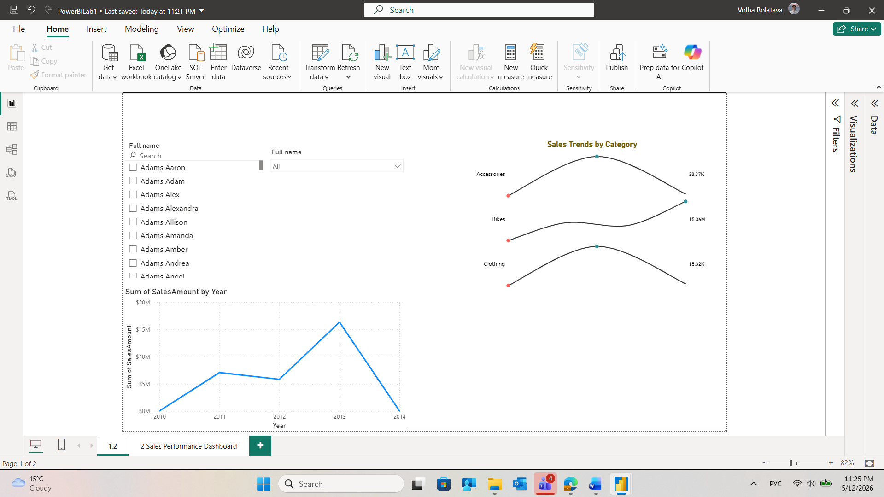
2. CREATE LAB REPORT
The report was developed using the AdventureWorks DWH dataset and is designed to serve as an executive-level analytical tool for sales performance monitoring. The report is structured around a clear visual hierarchy: high-level KPI indicators at the top provide immediate situational awareness, followed by segmentation and trend visuals that allow progressively deeper analysis.
To ensure visual coherence, a unified color palette was applied throughout the report — the accent colors correspond to the company logo, maintaining brand consistency across all chart types. A header section was added containing the report name and company logo.
To satisfy the interactive filtering requirements, three slicer types were implemented: a Dropdown slicer (Order Day), a List slicer (Region), and a Date filter (Order Date range). Additionally, a "Clear all filters" button was added to help users easily reset the report and explore the data more freely.
The report includes the following visual types: KPI Cards, Horizontal Bar Chart, Line Chart, Area Chart, Treemap and a Map visual — all from the standard Power BI library — complemented by two custom visuals from AppSource: Sparkline by OKVIZ and Inforiver Analytics+. The rationale for each custom visual is detailed in the corresponding sections below.
To preserve analytical integrity, the interaction between the Product Category slicer and the Sales by Category column chart was explicitly disabled, keeping the category overview as a fixed reference point.
- KPI Scorecards (Executive Summary)
- Purpose: To present the three most critical health indicators: Total Revenue, Items Sold, Average Tax per Order and Total Customers.
- Rationale: These high-level metrics provide immediate context.
- Horizontal Bar Chart (Customer Segmentation)
- Purpose: To identify and rank the Top 5 Customers by total sales volume.
- Rationale: Using a horizontal orientation allows for easy reading of long names and provides a clear visual ranking. This is essential for identifying key accounts that require high-touch relationship management.
- Implementation: the filter for top 5 customers was implemented through pannel “filters” – ‘filters on visual”
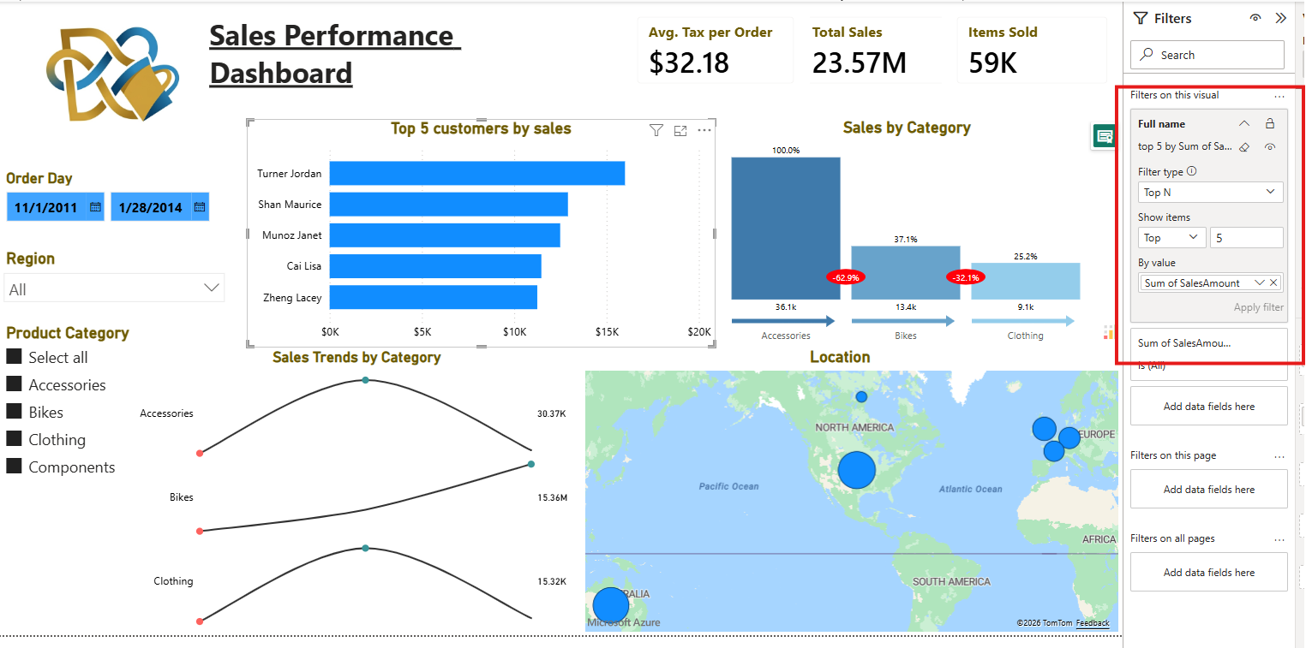
- Column Chart (Category Distribution)
- Purpose: To analyze the volume of sales across categories : Accessories, Bikes, and Clothing.
- Rationale: This visual highlights the product mix. It demonstrates how different categories perform relative to one another, making it easy to spot where the majority of the items sold are concentrated.
- Implementation: custom visual ‘Inforiver Analytics+ (100+ Charts, Gantt, Cards, Table) was added to the report. The main benefits are conditional formatting, thresholds, & data-driven styling, interactive controls: lasso, inverse lasso, dynamic chart switching, filter-aware annotations, small multiples, & export, built-in analytics, deviation & comparison analysis: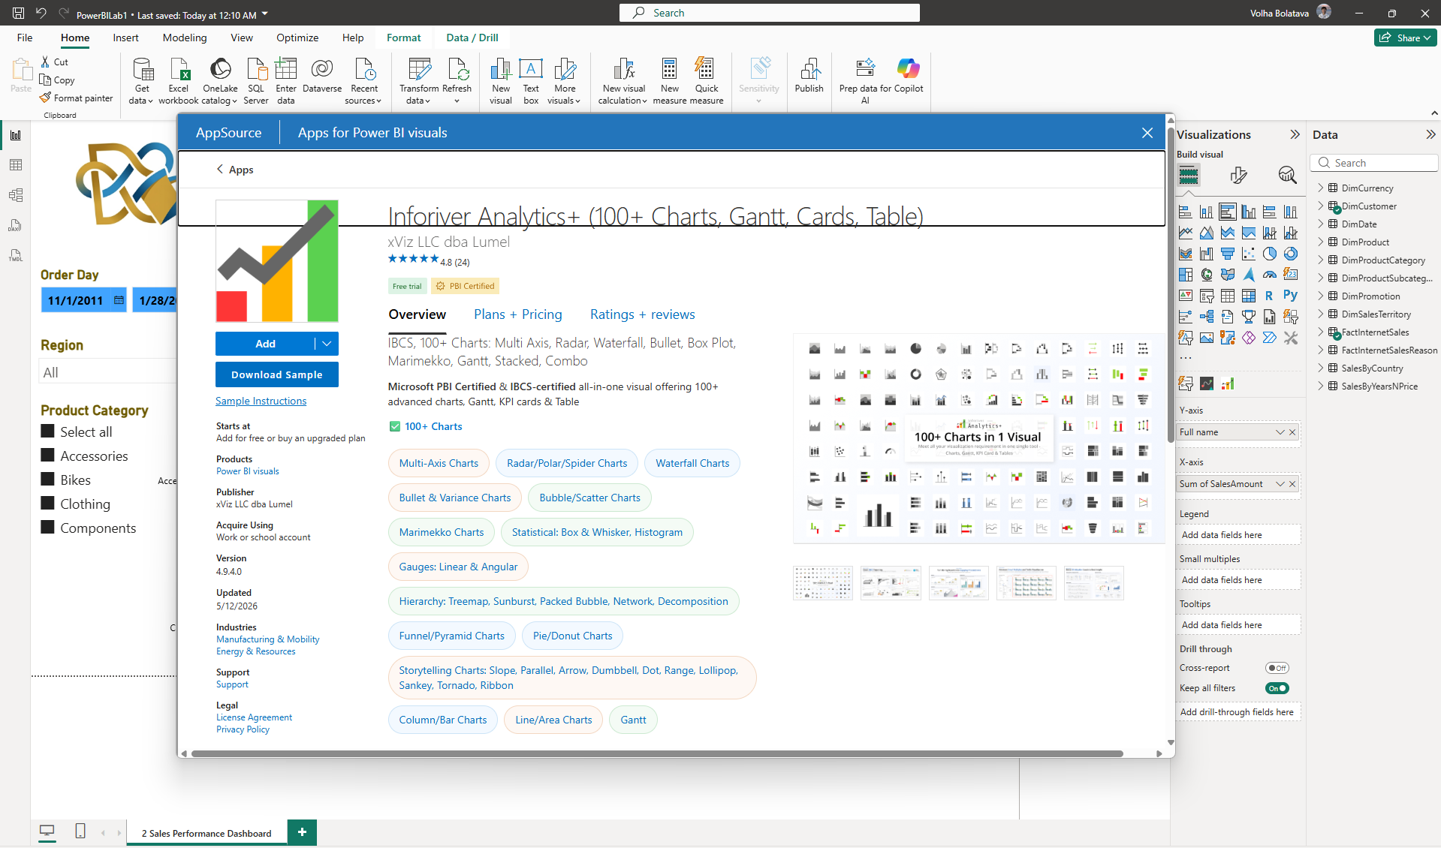
Сonditional formatting & data-driven styling was used.
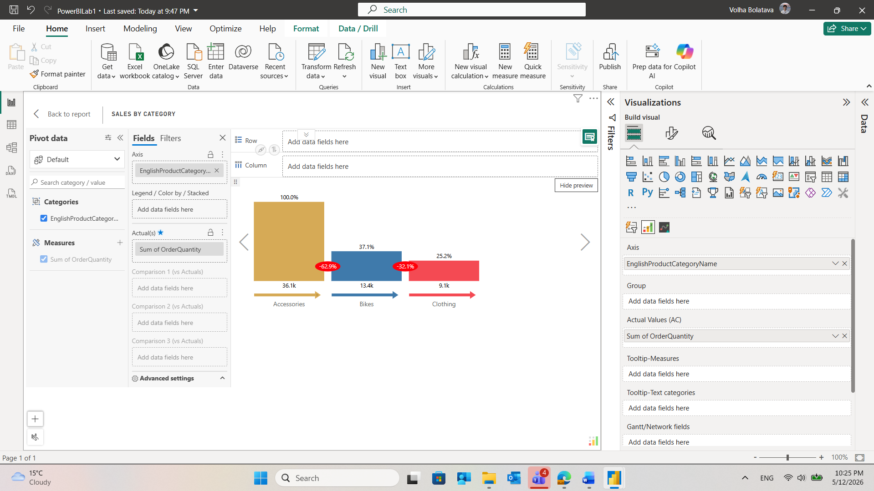
Each column displays both absolute values and relative percentages, providing a comprehensive view of the sales mix. Indicators quantify the drop in volume between categories. These percentage variances alert management to the magnitude of performance differences, facilitating discussions on inventory balancing and cross-selling strategies.
Column Chart Filtering Logic was applied to Column Chart to maintain a fixed reference point for category-wide performance, ensuring the Column Chart (Sales by Category) remains static when the Product Category slicer is used. This intentional design choice ensures that the user maintains a global perspective of the entire product mix while simultaneously analyzing the specifics of a single category. After selecting the Product Category slicer, the interaction for the Column Chart was explicitly set to "None" (the prohibited icon). This decouples the specific slicer from the visual while allowing other filters, such as Region or Time, to still function normally.
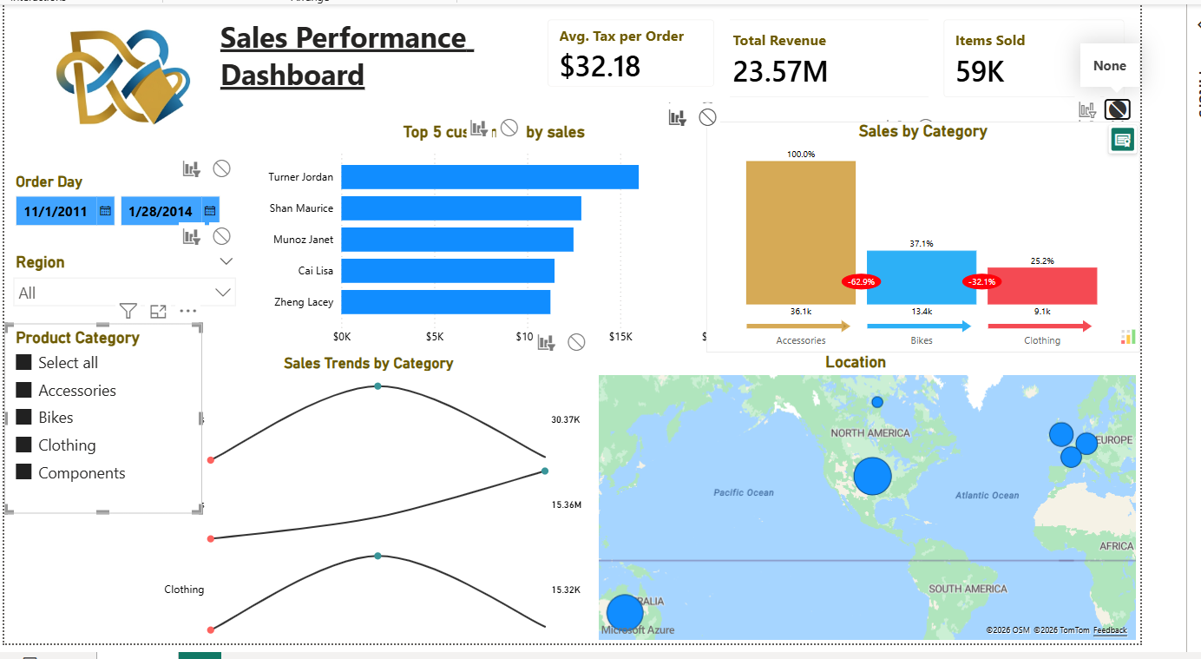
Result (The "Sales by Category" column chart remains unfiltered despite the selection):
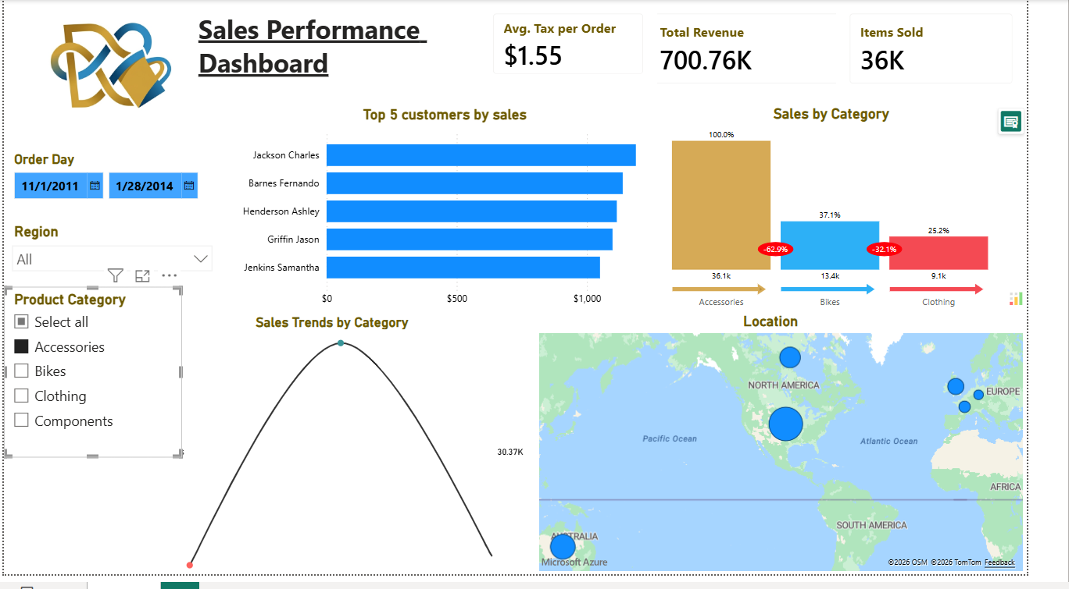
- Line Chart (Sales Trends by Category):
- Purpose: to identify seasonality and growth patterns across different product segments.
- Rationale: It allows stakeholders to pinpoint specific months or quarters where sales spike or drop, providing critical insights for inventory planning and marketing campaigns. By plotting multiple lines on a single axis, the chart highlights the divergence or convergence of categories—such as when "Accessories" might be growing while "Bikes" remain stagnant.
- Implementation: custom visual ‘Sparkline by OKVIZ ‘was added to the report. The OKVIZ custom visual is specifically configured to maintain a clean, minimalist design with distinct data points, ensuring high readability even when processing complex, multi-million row datasets. he sparklines are integrated into the dashboard’s grid to align with the overall minimalist aesthetic, providing a sophisticated layer of detail for experienced stakeholders.
- Geospatial Map (Territorial Analysis)
- Purpose: To visualize sales density across global regions.
- Rationale: The map provides a spatial dimension to the data, allowing management to identify geographic clusters of high performance or untapped market potential.
- Dynamic Slicers (Self-Service Discovery)
- Purpose: To provide interactive filtering by Order Day, Region, and Product Category.
- Rationale: Slicers transform a static report into an exploratory tool. Users can drill down into specific segments without requiring technical assistance or additional report pages.
- Area Chart (Sales vs. Cost Analysis)
- Purpose: To visualize the relationship between total sales and product costs over months and quarters.
- Rationale: chart allows for an immediate comparison of revenue margins. By using an area format, it highlights the volume of profit (the gap between the lines) and identifies specific periods of high expenditure or peak sales performance.
- Treemap (Regional Order Volume)
- Purpose: To show the proportional distribution of order quantities across different countries.
- Rationale: Treemap is highly effective for hierarchical data visualization. It enables stakeholders to quickly identify top-performing markets, by the size of the rectangles, providing a clear view of global market share.
Mobile layout was configured for the report :
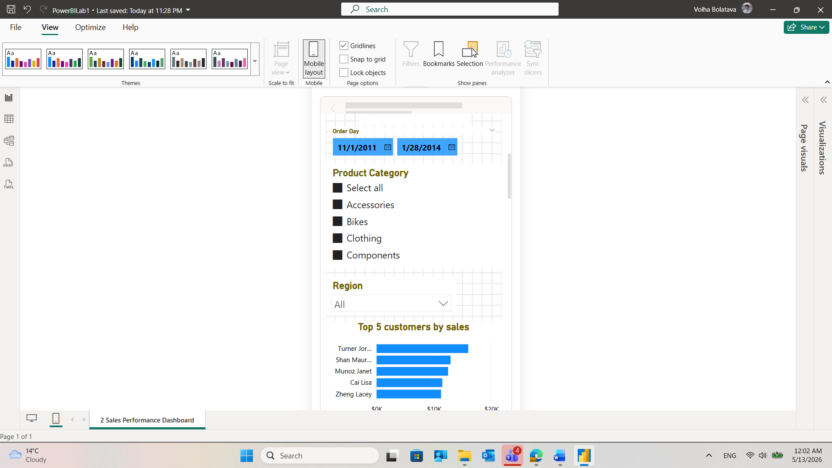
Report was published to Power BI Service Portal:
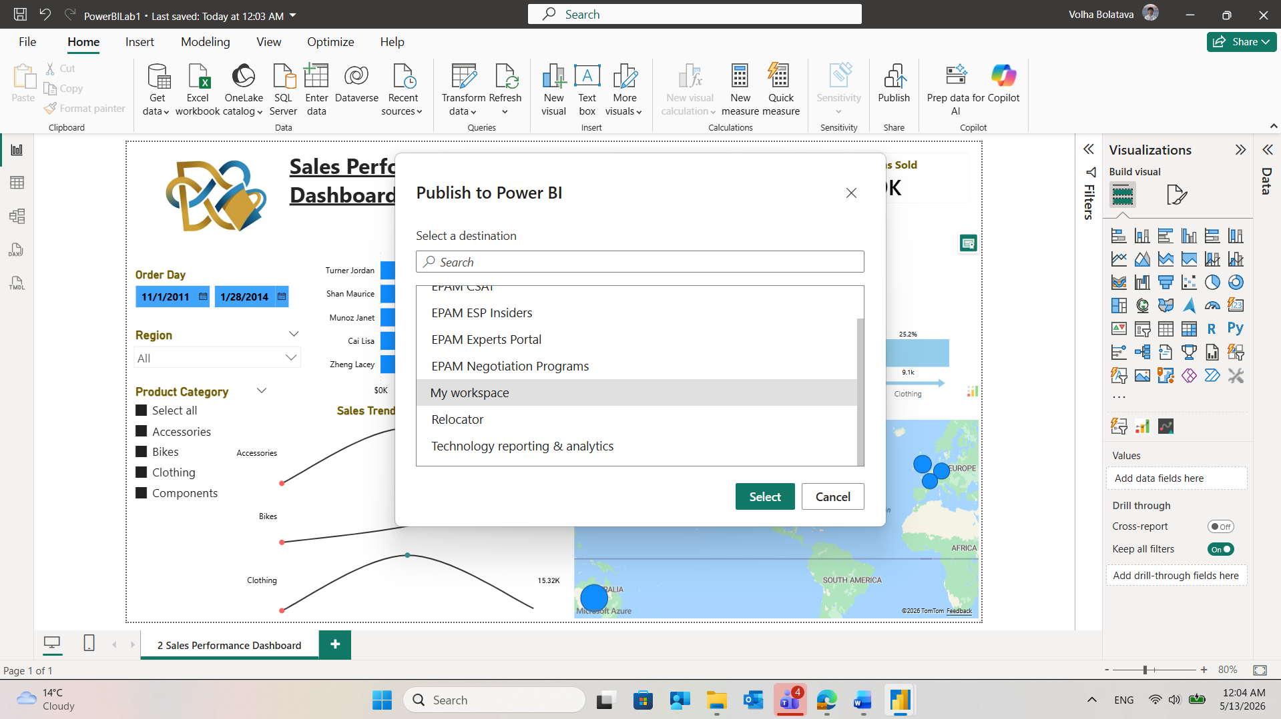
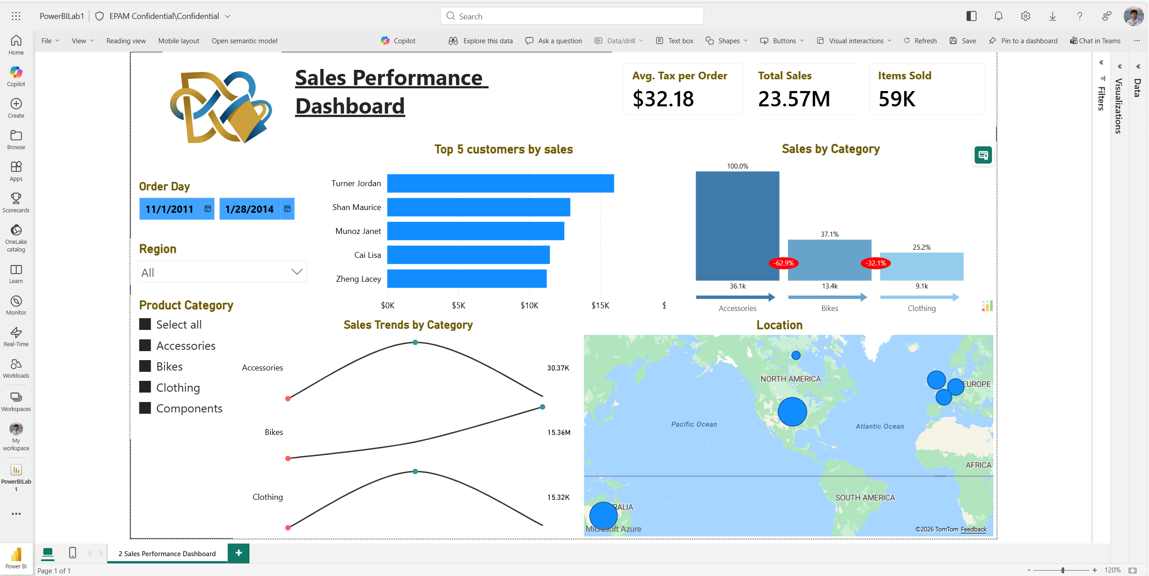
As the visualization Inforiver Analytics+ requires licenses to publish the report it was replaced with Clustered column chart .
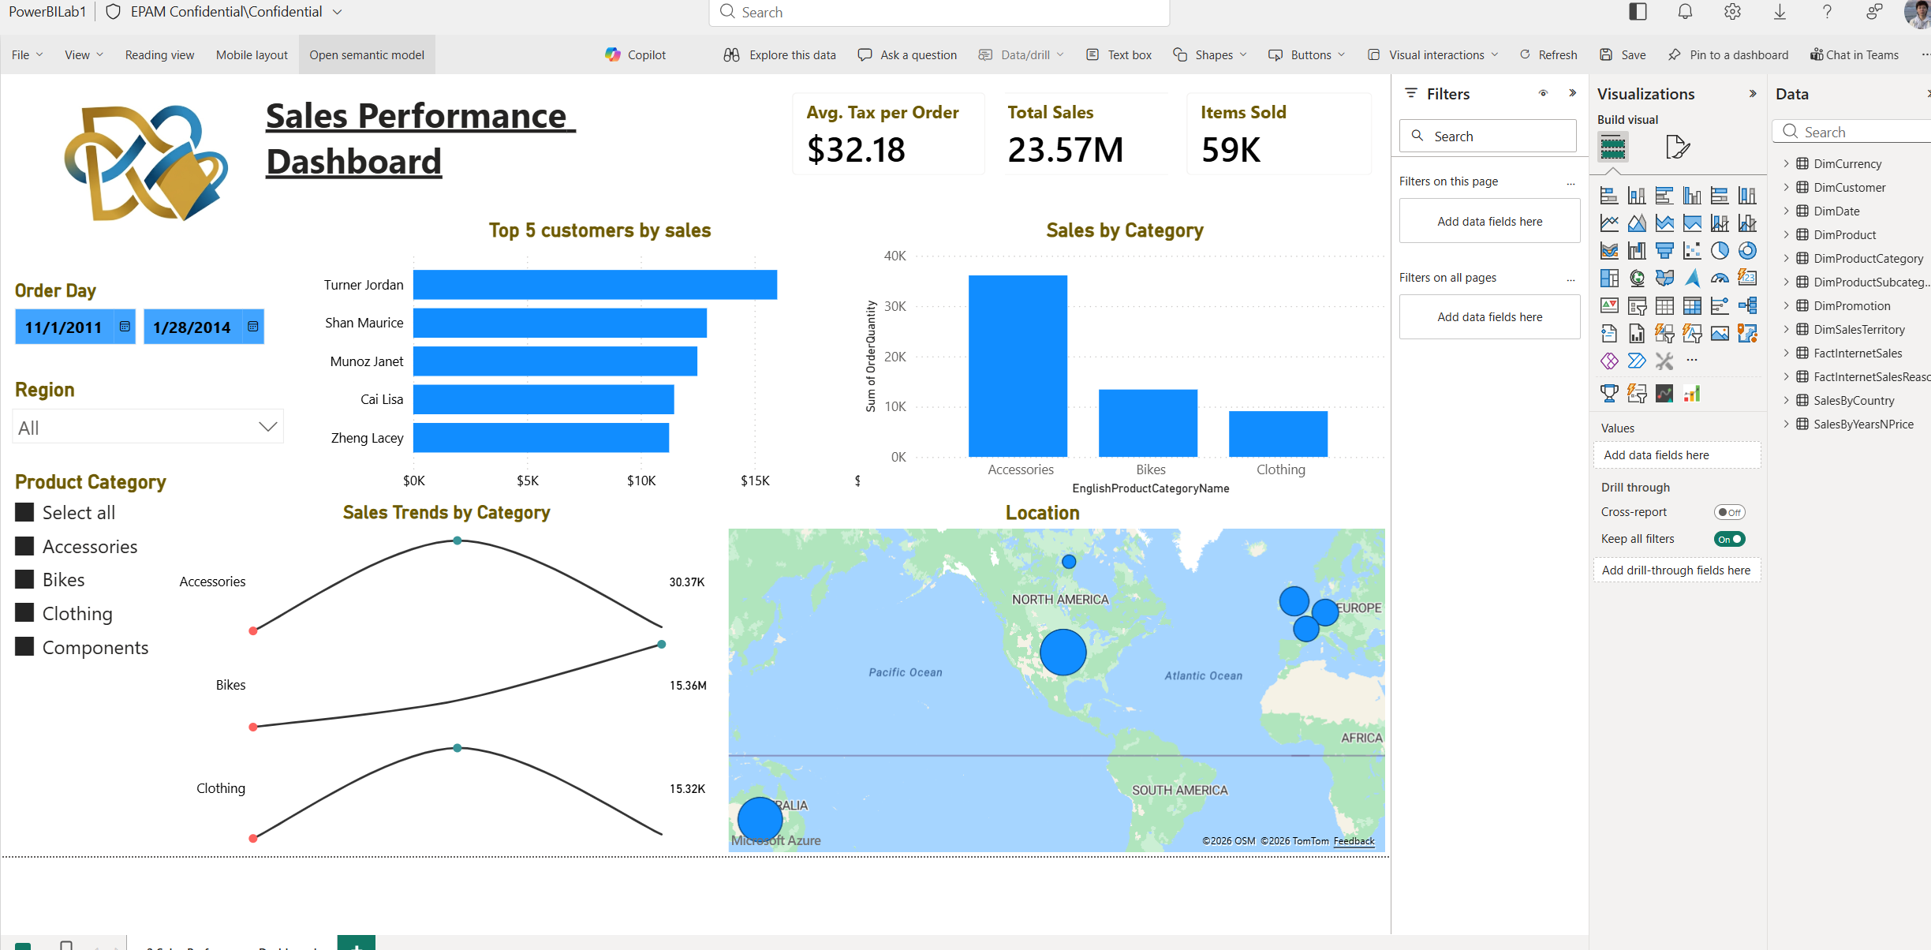
To enable automatic data refresh, the On-premises data gateway (personal mode) was installed on the local machine. After successful installation, the gateway was registered using the organizational Microsoft account associated with the Power BI Service workspace. The gateway status was confirmed as Running on the local machine
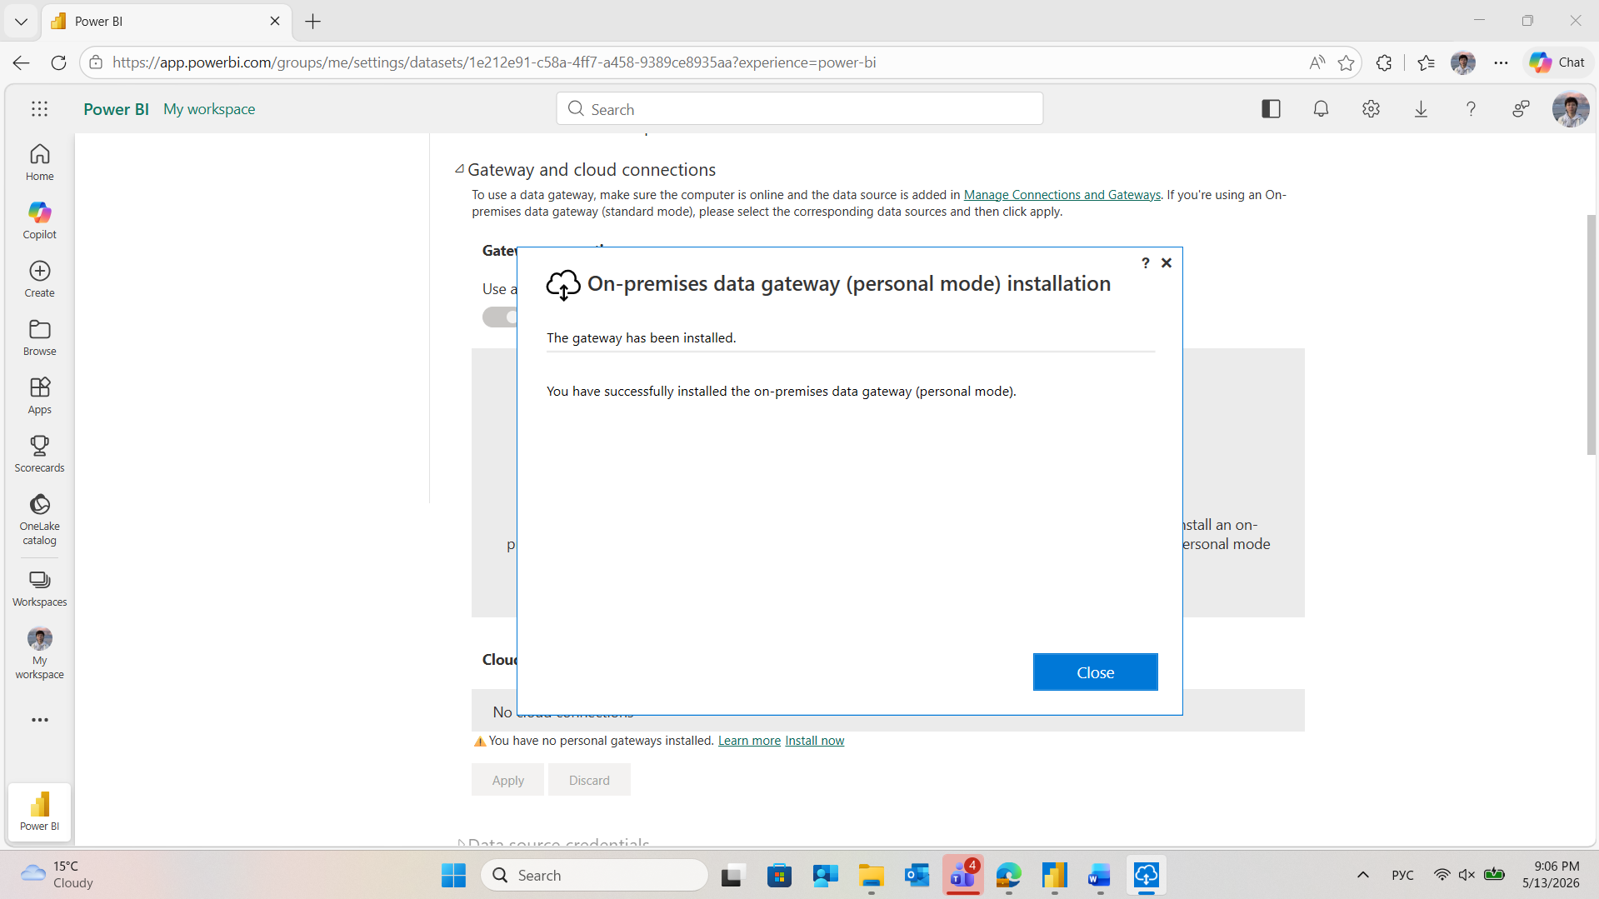
In the dataset settings for PowerBILab1, the Personal Gateway was selected as the data gateway connection for the AdventureWorksDW2017 SQL Server source. Data source credentials were configured using Windows authentication with Organizational privacy level.
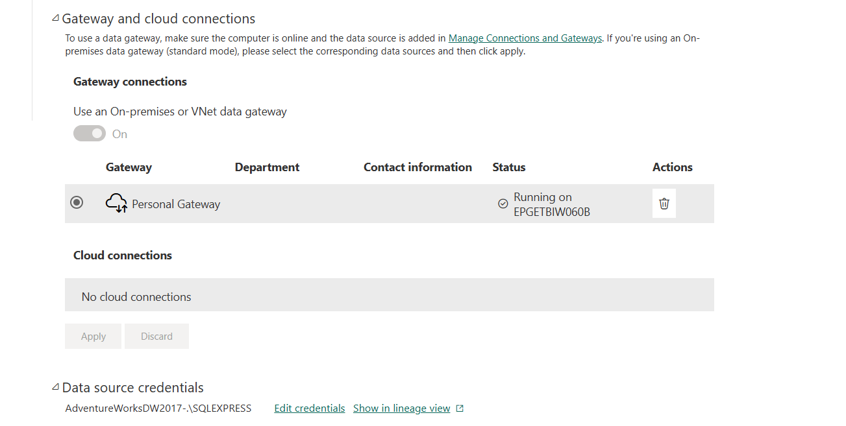
The scheduled refresh was configured as follows: refresh frequency set to Daily, time set to 1:00 PM UTC. The configuration was saved and is active. The screenshot of the configured refresh schedule is provided below:
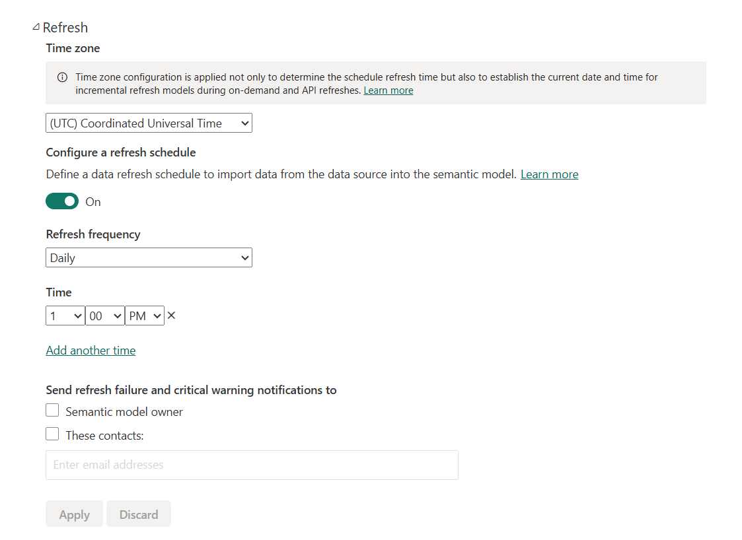
Report was shared :
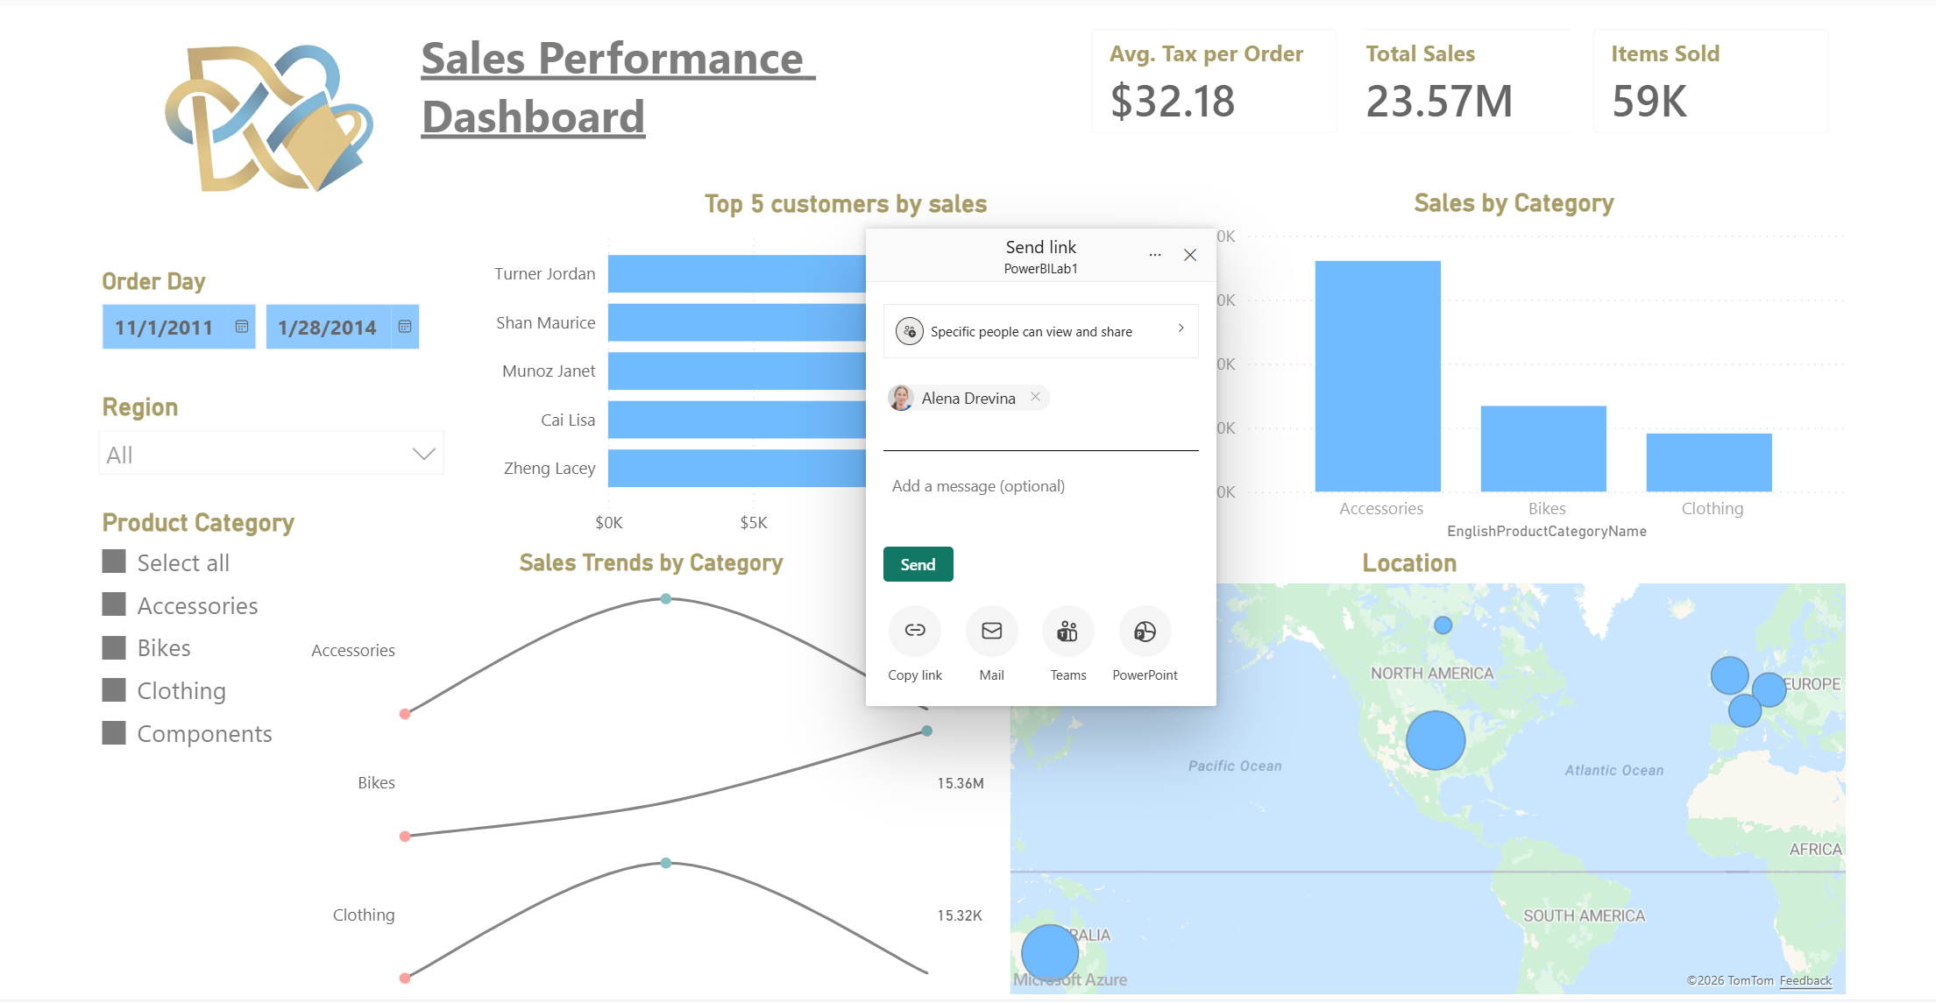

The report sharing feature requires a Power BI Pro or Premium Per User (PPU) license for both the report owner and the recipient. As the current account operates under a free license, this functionality is restricted.
To share the report, the following steps should be performed: open the report in Power BI Service, click the Share button in the top menu bar, enter the mentor's email address, enable the "Send an email notification" option, and confirm with Can view access level. The mentor would then receive an email with a direct link to the report.
Power BI Service supports built-in URL filtering using the following syntax:
?filter=TableName/ColumnName eq 'Value'
The following link opens the report pre-filtered by 'Germany':
https://app.powerbi.com/groups/me/reports/2e26f50c-b71d-4b86-8db1-3b81a2ff121f/b6c5791cf58ef7d8b914?experience=power-bi&filter=DimSalesTerritory/SalesTerritoryCountry eq 'Germany'
